**Configurator Meta-model**

**Group 05 (A. Church)**

**Ole Ertmann Nielsen**

**Rasmus Lohals Larsen**

**Sten Anderson**

**Morten Egelund Rasmussen**

# 1. Configurator meta-model

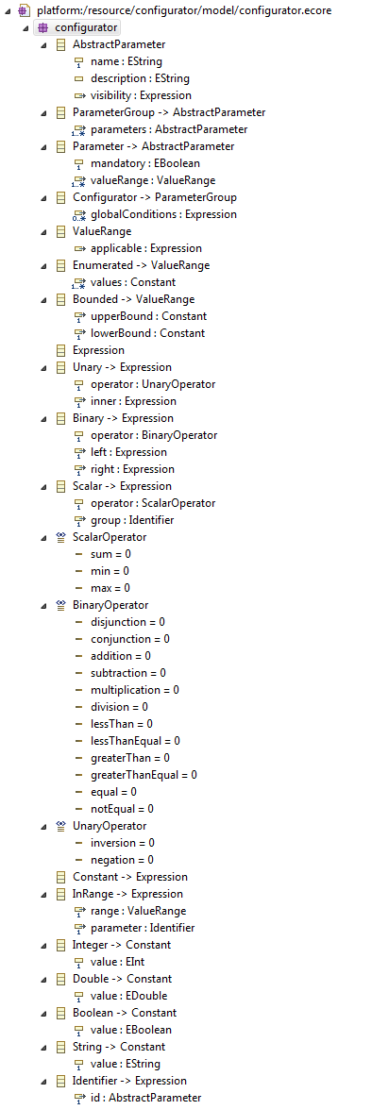

# 2. Class diagram

